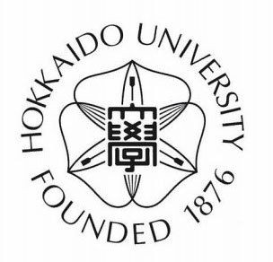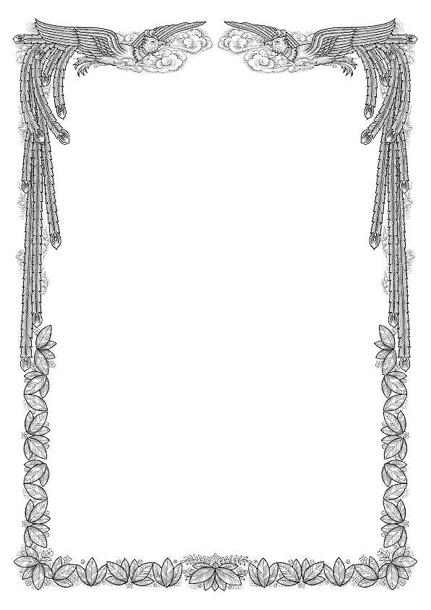

**GRANT APPROVAL**

To: Rakhmankulov A, Al-Farabi Kazakh National University, Faculty of International Relations

Hokkaido University has decided that the above-mentioned person will be admitted to Hokkaido University as an Exchange Student (Japanese Government Scholarship Student) from September 2020 to September 2021.

Gross amount of Grant:

**USD 16400**

October 06, 2020

Hokkaido University